Retrievers
28.06.2025

Retrievers
A Retriever is a component in Langchain that fetches relevant documents from a data source in response to a user’s query.
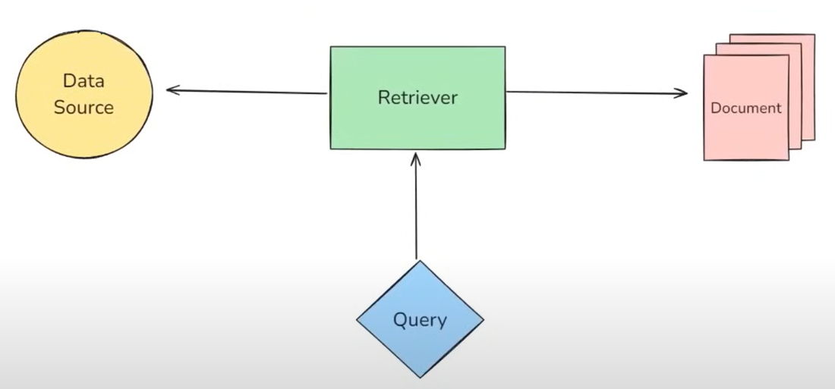
We have multiple types of retrievers. All retrievers in Langchain are runnables.
On the basis of Data Source and Searching strategy we have different types of retrievers.

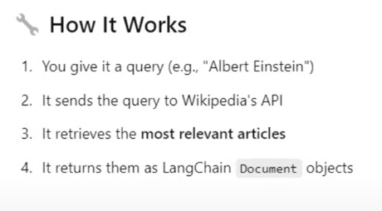

On the basis of Data Source :

- Wikipedia Retriever - that queries Wikipedia API to fetch relevant content for a given query.

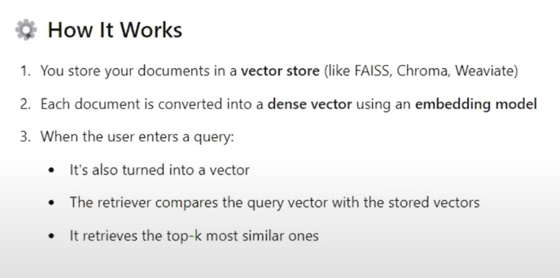
- Vector Store Retriever -
the most common type of retriever that lets you search and fetch documents from a vector store based on semantic similarity using vector embeddings.

On the basis of Semantic Searching :
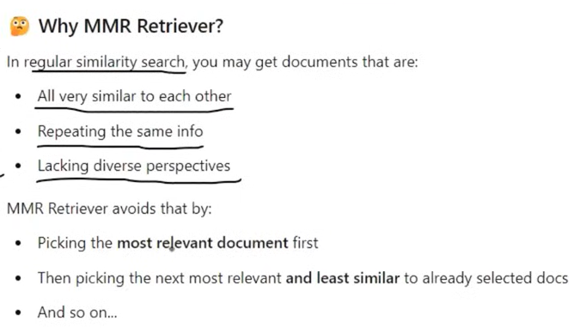
- Maximal Marginal Relevance (MMR)
Algorithm designed to reduce redundancy in the retrieved results while maintaining high relevance to the query.

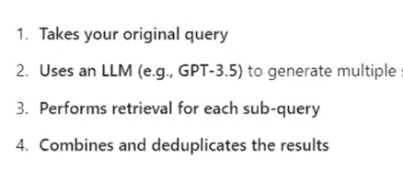
- Multi-Query Retriever
A single query is asking for a wider scope of answers. Query is being given to the LLM that gives multiple different questions from it which gets most relevant answers , among them most relevant ones are being provided in return to the query.

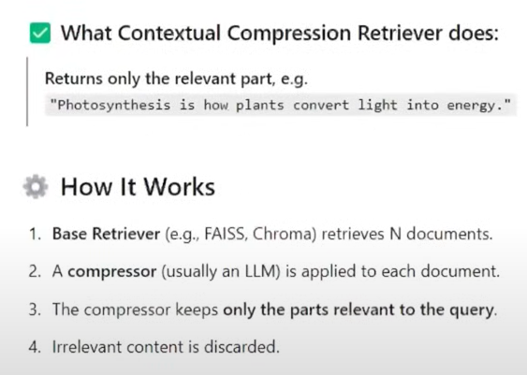
- Contextual Compression Retriever
Advanced retriever that improves retrieval quality by compressing documents after retrieval keeping only relevant content based on the user’s query.

